The transcription chart

What is the transcription chart and how will it help my speech?
The transcription chart, also known as the international phonetic alphabet chart, was formulated by the international phonetic association in the 19th century. It was based on the Latin alphabet.
It is popular with linguists and contains symbols. These symbols represent sounds in spoken English, not other languages. The international phonetic alphabet chart is based on the received pronunciation accent, which is widely regarded as the standard accent in the UK and abroad. This is central to know when studying the language.
In total, the international phonetic alphabet chart has 44 sounds which are known as ‘phonemes’. The ‘phonemes’ are written as symbols and each helps with perfecting speech. As English has a lot more pronunciation exceptions than other languages, it is central to know the chart as a spelling of a word does not always tell us how we hear it
Take the word bought for example (which is the past of the verb buy). Its spelling makes the reader think it should sound like how it is written. In reality, it sounds more like this: bort.
This should make the English language easier. Let’s take a look deeper below.

Transcription chart structure
There are three important areas to consider when looking at this. The chart is divided into vowels and consonants and each of them have their own symbols.
In the vowel section, it is divided into two sections: monophthongs and diphthongs.
These sound like difficult words, but they will be easier to grasp after these definitions.
Monophthongs : a word with a single sound vowel, such as slip or sleep.
Diphthongs: a combination of two vowels, which sounds like one vowel when put together. For example, coin or loud.
The consonant section is not divided into two sections and has 24 symbols, whilst the vowel section has 20 symbols.
Are you ready to take a closer look at monophthongs and diphthongs and hear their characters?
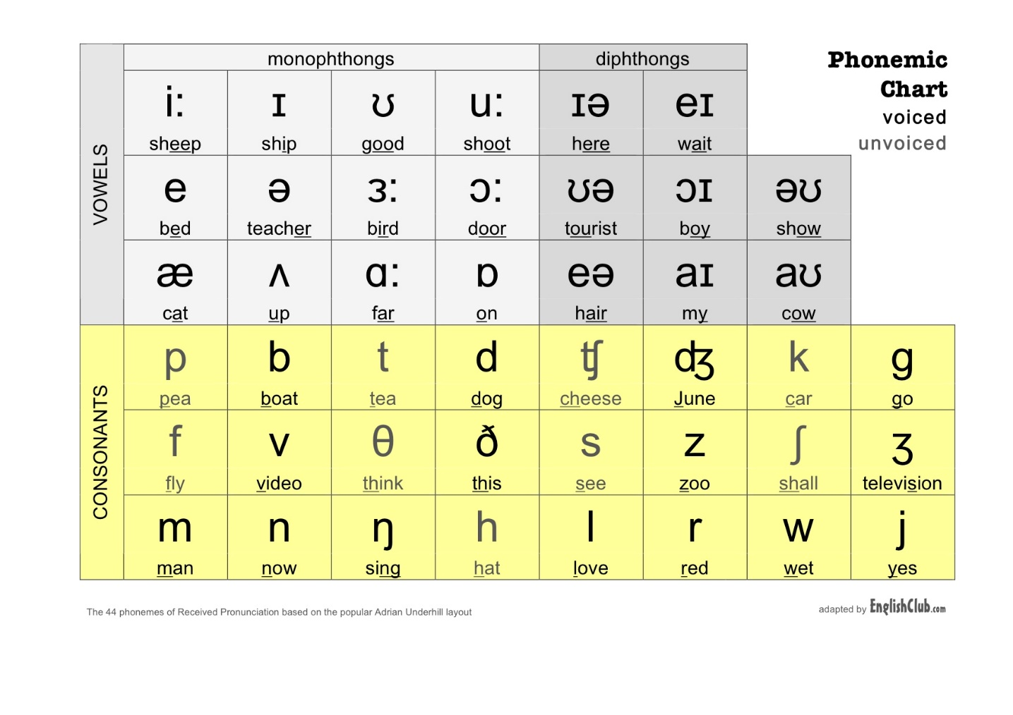

Monophthongs in the IPA chart
Take a look at the monophthongs section.
Of course, there are plenty more words that can be included in each of the sections. Take a look at this table.
i:
Me, see, need, be, leave.
ɜ:
Earn, learn, turn, yearn, churn.
I
Pit, sit, with, this, wink.
ɔ:
Oar, or, floor, bore, chore.
ʊ
Foot, cook, look, book, hook..
æ
Map, cat. bad, pack, sand.
u:
To, new, you, shoe, cool.
ʌ
Mud, bus, shut, but, up.
e
When, men, said, leg, hen, head.
ɑ:
Palm, calm, cart, smart, start.
ə
Letter, power, flower, tower, shower.
ɒ
Lot, cot, dot, pot, on.

Diphthongs
Like monophthongs, take a look at the diphthongs section and the table below for more examples.
ɪə
Ear, cheer, year, deer, fear.
əʊ
Go, bow, sew, so, flow.
eɪ
Say, pray, day, way, stray.
eə
Air, chair, rare, bare, there.
ʊə
Tour, sure, cure.
aɪ
I, eye, pie, fight, fright.
ɔɪ
Oil, coin, boy, voice, boil.
aʊ
Owl, out, count, bow, cowl. 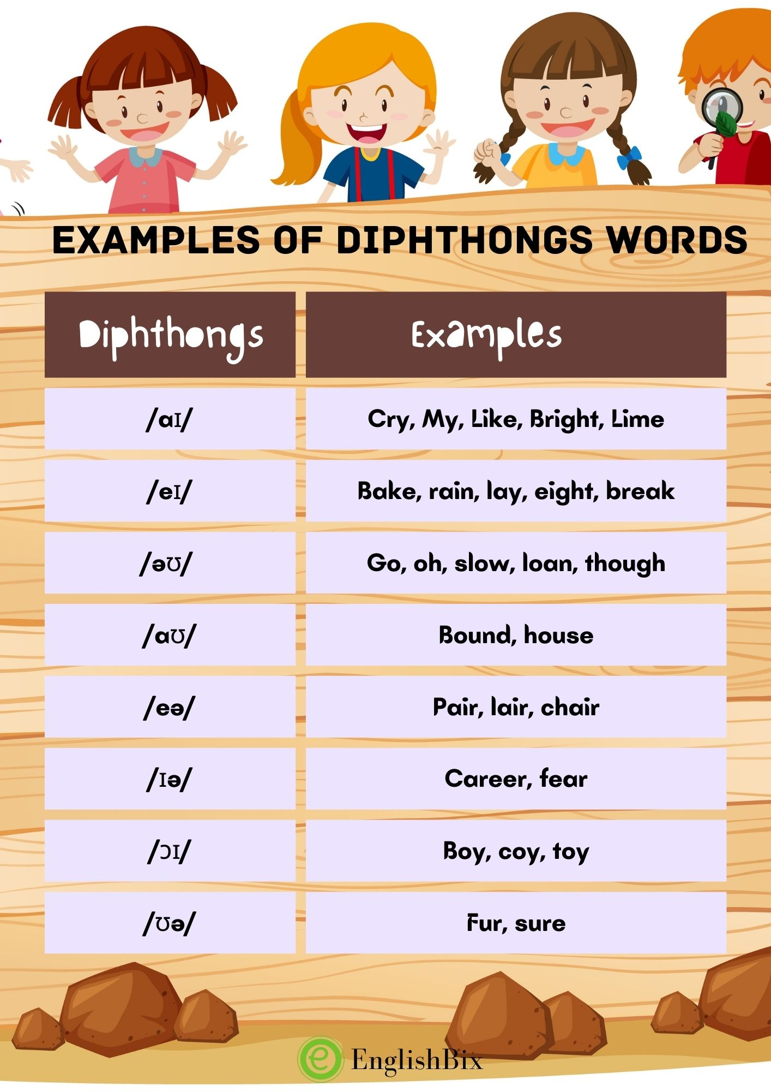

Consonants
Consonants are the biggest section as they have 24 symbols. Remember, they are not divided into sections like vowels. Hear them below.
As with the vowel section, take a look below for more examples.
p
Pay, happy, pet.
ʧ
Choke, watch, catch.
b
Best, trouble, tub.
f
Fine, offer, off.
s
Miss, face, snake.
v
Vine, of, save.
t
Mat, tile, flat.
ʃ
Show, push, rush.
d/
Dip, sad, mad.
θ
Thin, both, method.
k
Cat, back, talk.
ð
With, then, other.
ʤ
Joke, June, large.
g
Game, bag, big.
n
Nail, fun, nine.
z
Crazy, lazy, phase.
h
He, heal, hill.
ŋ
Sing, fling, wing.
ʒ
Measured, treasure, pleasure.
m
Some, mail, mum.
r
Real, courage, umbrella.
l
Love, like, follow.
w
We show, wheel.
j
You, beyond, yacht.
